Project Name Title
Farm Source

Revision History

Process Version # | Date | Author | Revision Description
1.0 | dd/mm/yyyy | Author Name | Initial version
Purpose
A summary with a goal you need to achieve with this project.
- Project Requirements
These are the required steps for this project:
  - – Requirement AAAAAAAA
  - - Requirement BBBBBBBB
  - - Requirement CCCCCCCC
- Development
All the development has been controlled and versioned by Bitbucket under the project folder:
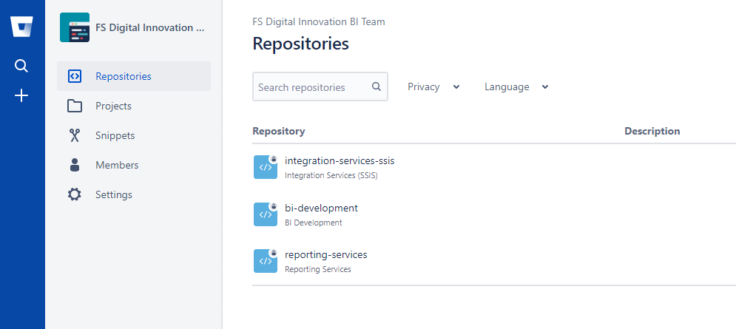
Link:
https://bitbucket.org/fs-digital-innovation-bi-team/bi-development/src/master/TRA%20Automation%20for%20FEM%20-%20Weekly%20Samples/

- Roadmap
This is the roadmap for this project including all the steps and timeline, starting and ending time:
https://teams.microsoft.com/l/file/196530C1-53F8-4A03-BA4D-ABB37DDACE3F?tenantId=c5d7dc78-3f45-4492-8053-9441aee4531b&fileType=xlsx&objectUrl=https%3A%2F%2Ffonterra.sharepoint.com%2Fsites%2FFSDigitalInnovationBITeam%2FShared%20Documents%2FFarmer%20Experience%20Monitor%20Discussions%2FRoadmap%2FTRA%20Automation%20for%20FEM%20-%20Weekly%20Samples%20-%20Roadmap.xlsx&baseUrl=https%3A%2F%2Ffonterra.sharepoint.com%2Fsites%2FFSDigitalInnovationBITeam&serviceName=teams&threadId=19:861d0f2c049944d6b236de38b1ea40f5@thread.tacv2&groupId=1a1501e9-957a-4ed6-8aa6-cf09d31f2e19

- Documentation
All the documentation is in MS Teams, accessed via SharePoint as well:
https://teams.microsoft.com/l/channel/19%3a861d0f2c049944d6b236de38b1ea40f5%40thread.tacv2/Farmer%2520Experience%2520Monitor%2520Discussions?groupId=1a1501e9-957a-4ed6-8aa6-cf09d31f2e19&tenantId=c5d7dc78-3f45-4492-8053-9441aee4531b

